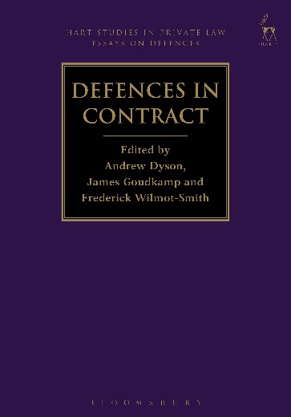
Defences in Contract
Edited by Andrew Dyson, James Goudkamp and Frederick Wilmot-Smith

This book is the third in a series of essay collections on defences in private law. It addresses defences to liability arising in contract. The essays range from those adopting a predominantly black-letter approach to others that examine the law from a more theoretical or historical perspective. Some essays focus on individual defences, while others are concerned with the links between defences, or with how defences relate to the structure of contract law generally. One goal of the book is to determine what light can be shed on contract law doctrines by analysing them through the lens of defences. The contributors – judges and academics – are all leading jurists. The essays are addressed to all of the major common law jurisdictions.

Andrew Dyson is an Assistant Professor in Private Law at the London School of Economics and Political Science.
James Goudkamp is a Fellow of Keble College and an Associate Professor in the Oxford Law Faculty. He is also an Associate Academic Fellow in the Honourable Society of the Inner Temple, a Senior Honorary Research Fellow in the Faculty of Law, University of Western Australia, a Professorial Fellow in the School of Law, University of Wollongong and a barrister at 7 King’s Bench Walk.
Frederick Wilmot-Smith is a Prize Fellow at All Souls College, Oxford.

February 2017 | 9781849467230 | 336pp | Hardback | RSP: £75
Discount Price: £60
Click here to order online and use the discount code CV7 at the checkout to get your 20% off

